Assignment: Topic Research & SEO-Optimized Blog Creation

Blog Topic:
Authentic Traditional Sweets of Bengal
Submitted by Puja Karmakar
Batch: Digital Marketing with AI (Batch 471)

TABLE OF CONTENTS
SL NO | DESCRIPTION
1 | Topic Research
2 | Keyword Research and Clustering
3 | The SEO-Optimized Blog
4 | Image Optimization
5 | Technical SEO Elements
6 | Plagiarism check
7 | Conclusion

Step 1: Topic Research
1.1 Niche: Food
Topic: Traditional Food
1.2 Trending 2 Topic:
- Traditional Food of Bengal
- Traditional Sweets of Bengal

1.3 Final Selected Topic
Niche | Trending 2 Blog Topics | Finally selected Blog Topic
Food | 1. Traditional Food of Bengal  2. Traditional Sweets of Bengal | Traditional Sweets Of Bengal

1.4 Justification for choosing the Topics:

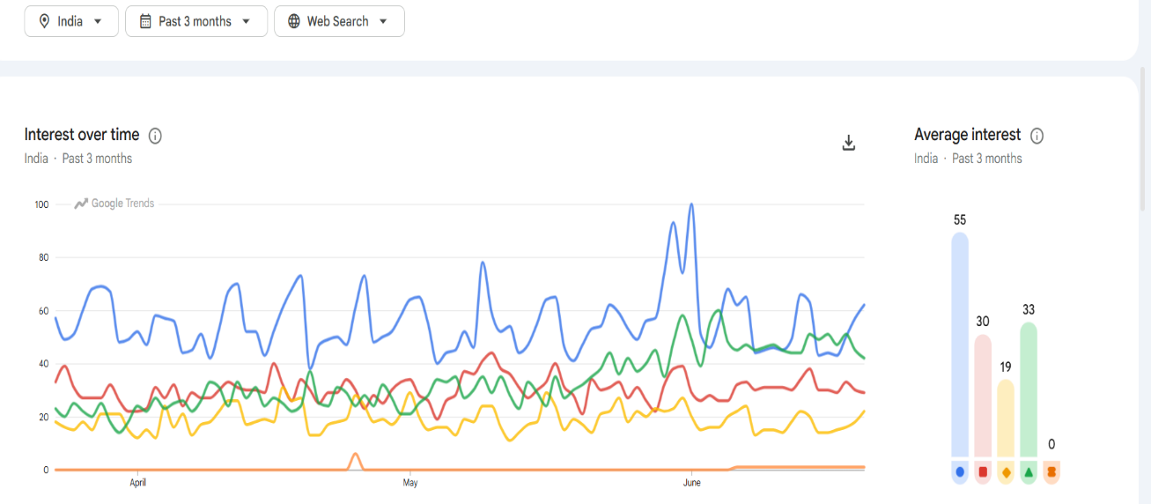
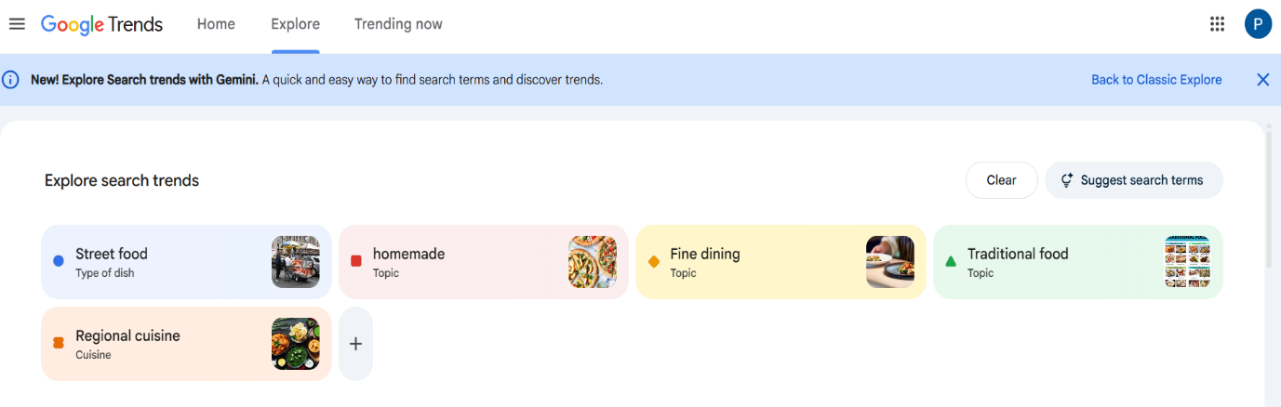
According to Google Trends, 2 most searched topics in my niche are Street Food & Traditional Food.
Based on this research, I selected Traditional Food and wrote a blog, “ Traditional Sweets of Bengal”.

Section 2: Keyword Research and Clustering Using Google Keyword Planner

Keyword | Avg. Monthly Search | Competition | Top of Page Bid(High Range) | Top of Page Bid (Low Range) | Keyword Type | Search Intent | Cluster Name
Traditional Sweets | 100-100k | Low | ____ | ____ | Focus | Informational | Traditional Sweets of Bengal
Mihidana | 1k-10k | Low | ____ | ____ | Additional | Informational | Traditional sweets of Burdwan
Sitabhog | 1k-10k | Low | ____ | ____ | Additional | Informational | The Golden Delight of Burdwan
Sweets | 100k-1M | Low | 12.82 | 0.74 | Additional | Informational | Bengal Traditional sweet
Traditional | 100k-1M | Low | 49.16 | 20.14 | Additional | Informational | Traditional sweets
Desserts | 100k-1M | Low | 50.23 | 5.02 | Additional | Informational | Traditional desserts

Section 3: SEO Optimised Blog
<h1>Authentic Traditional Sweets of Bengal: History & taste</h1>

<h2> Introduction</h2>
Traditional sweets are an important part of Bengal's culture and heritage. From festivals and family celebrations to everyday meals, desserts have always held a special place in Bengali life. Every region of West Bengal offers unique delicacies that people have enjoyed for generations. Burdwan proudly showcases Sitabhog and Mihidana, Kolkata delights sweet lovers with Rosogolla and Sandesh, and Krishnanagar, Jaynagar, Shaktigarh, and Murshidabad contribute their own traditional sweets that celebrate Bengal's rich history and heritage. These sweets are more than just desserts—they are symbols of tradition, craftsmanship, and love. Let's explore the history and flavours of some of the most popular traditional sweets of Bengal.
<h2>Traditional Sweets: A Sweet Heritage Of Burdwan<h2>
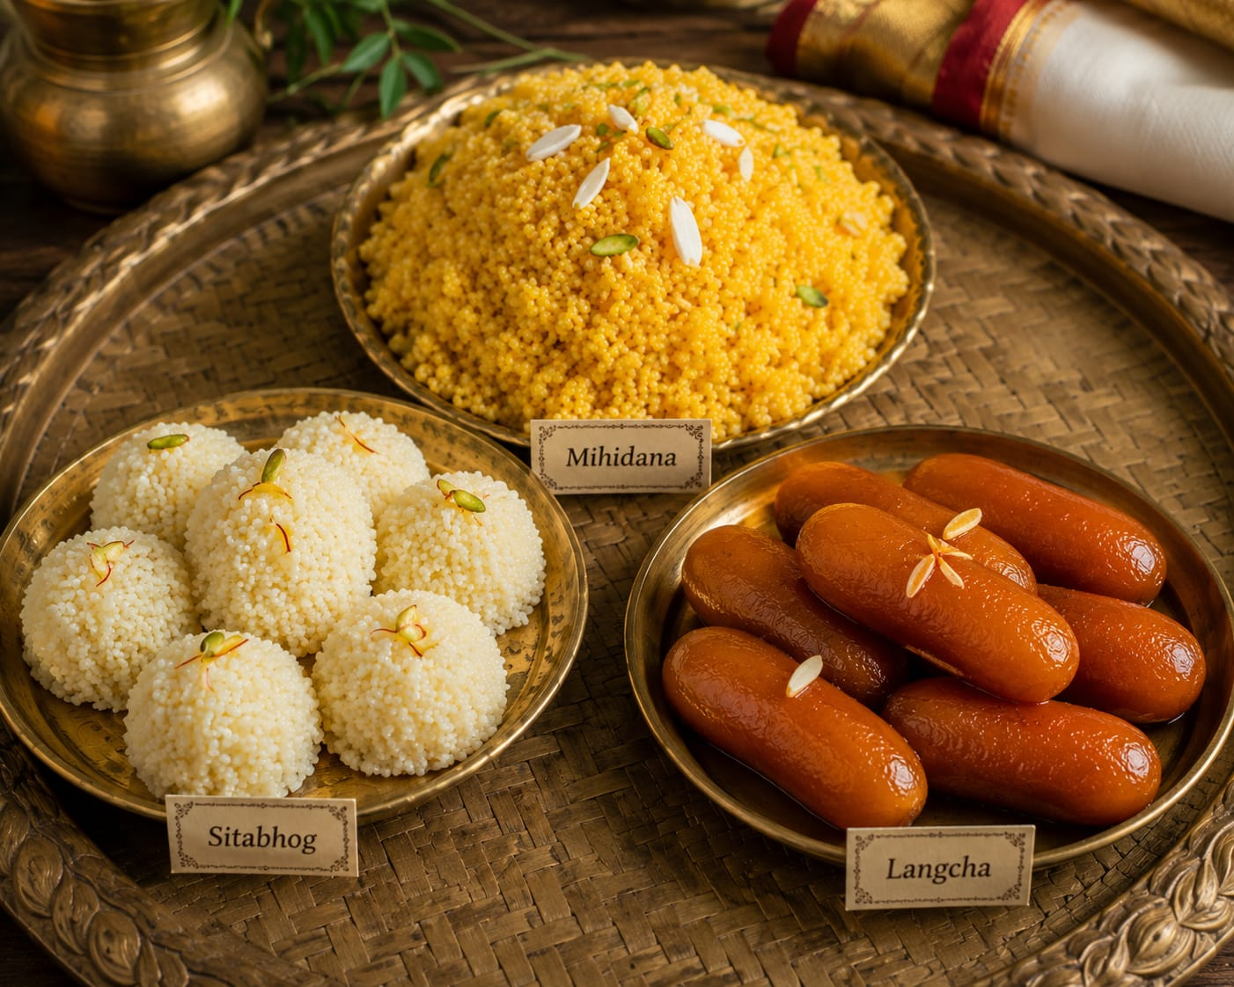
Burdwan is one of the most famous places in West Bengal for traditional sweets. Over the years, the district has preserved its unique recipes and rich sweet-making tradition. Consequently, it has earned a special place in Bengal's culinary heritage. Some of Bengal's most popular sweets, such as Sitabhog, Mihidana, and Langcha, originated here and continue to delight sweet lovers across the country.

<h2> The History of Burdwan Traditional Sweets</h2>
The history of Burdwan's traditional sweets goes back to the time of the Maharajas. Skilled sweet makers created new recipes that soon became famous throughout Bengal. Over the years, people have embraced these sweets as an important part of the district's identity. Consequently, families continue to enjoy them during festivals and special occasions.

<h3> Sitabhog: Burdwan's Royal Delicacy</h3>

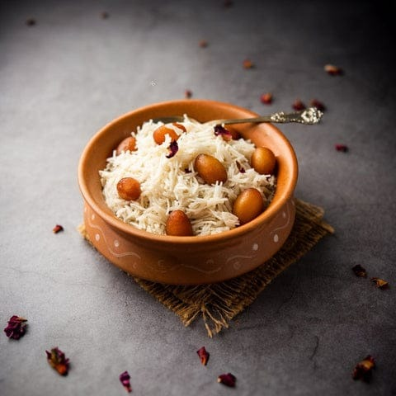

Sitabhog is one of the most famous traditional sweets of Burdwan. It is made from chhena, rice flour, and sugar. Although it looks like rice, it is actually a sweet dish with a soft texture and delicious taste. Bhairab Chandra Nag created Sitabhog, and over time, its unique identity earned it a GI tag. As a result, the sweet gained recognition for its rich heritage and distinctive taste.

<h3> Mihidana: The Golden Delight of Burdwan</h3>

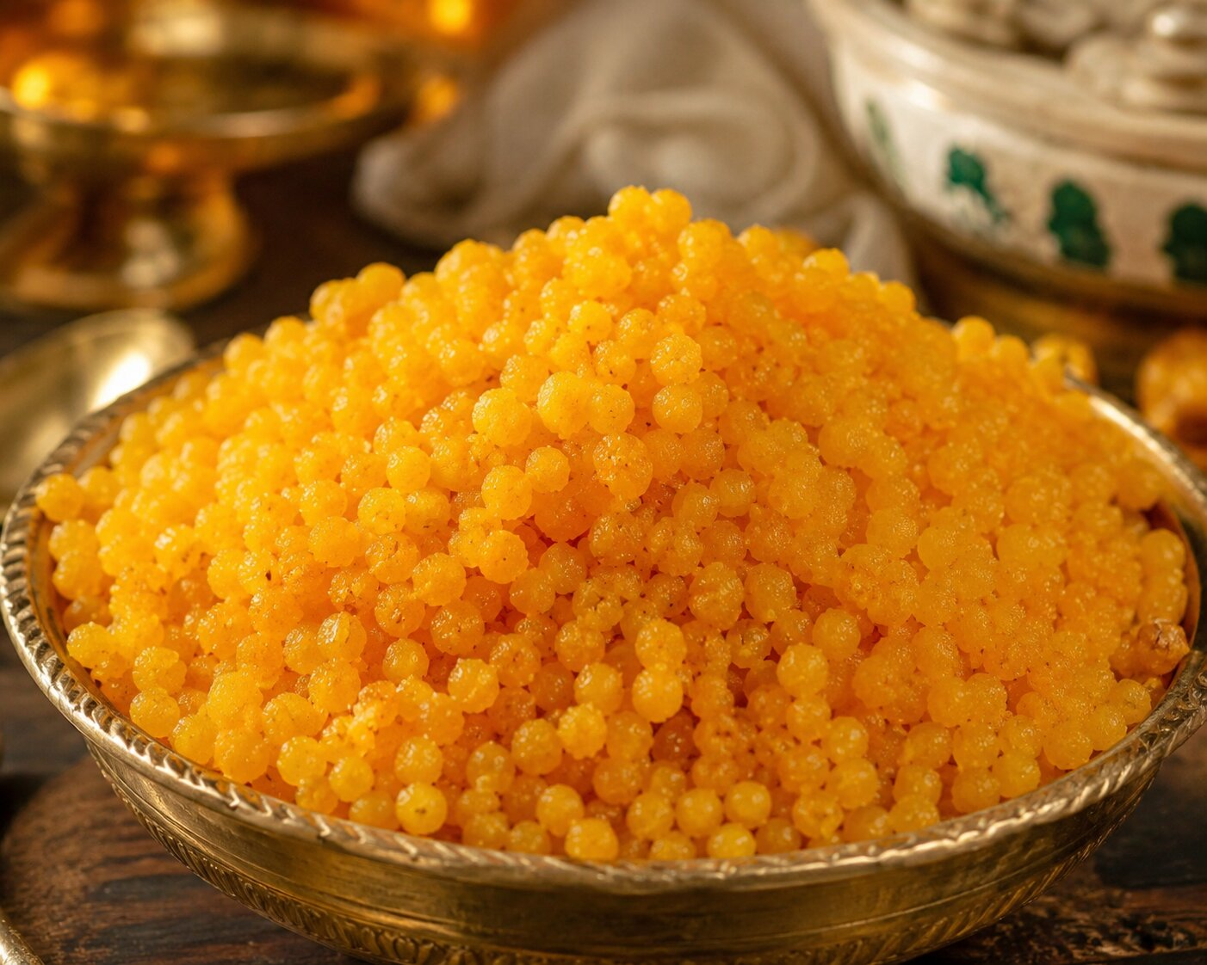

Mihidana is another popular sweet from Burdwan. It's making from tiny golden grains prepared with gram flour, rice flour, and sugar syrup. Its light texture and sweet flavor make it a favourite among people of all ages. Like Sitabhog, Mihidana has also received a GI tag.

<h3>Langcha: The Symbol of Shaktigarh</h3>

Langcha is a famous sweet from Shaktigarh in the Purba Bardhaman district. Prepared from chhena and khoya, deep-fried and soaked in sugar syrup. Its soft texture and rich taste have made it one of the most loved traditional sweets in West Bengal. Travellers often stop at Shaktigarh to enjoy this delicious treat.

<h3>Traditional Sweets: A Sweet Heritage of Kolkata:</h3>
Kolkata is often called the sweet capital of India. The city is home to many famous traditional sweets that have delighted people for generations. From soft Rosogolla to flavourful Sandesh, Kolkata's sweet shops have become a part of the city's culture and identity.

<h2>The History of Kolkata’s Traditional Sweets</h2>
The history of Kolkata's traditional sweets dates back to the nineteenth century when skilled confectioners began experimenting with chhena-based desserts. Over time, these sweets became popular across Bengal and beyond. Today, Kolkata is known around the world for its rich sweet-making tradition.
<h3>Rosogolla: The Pride of Kolkata</h3>
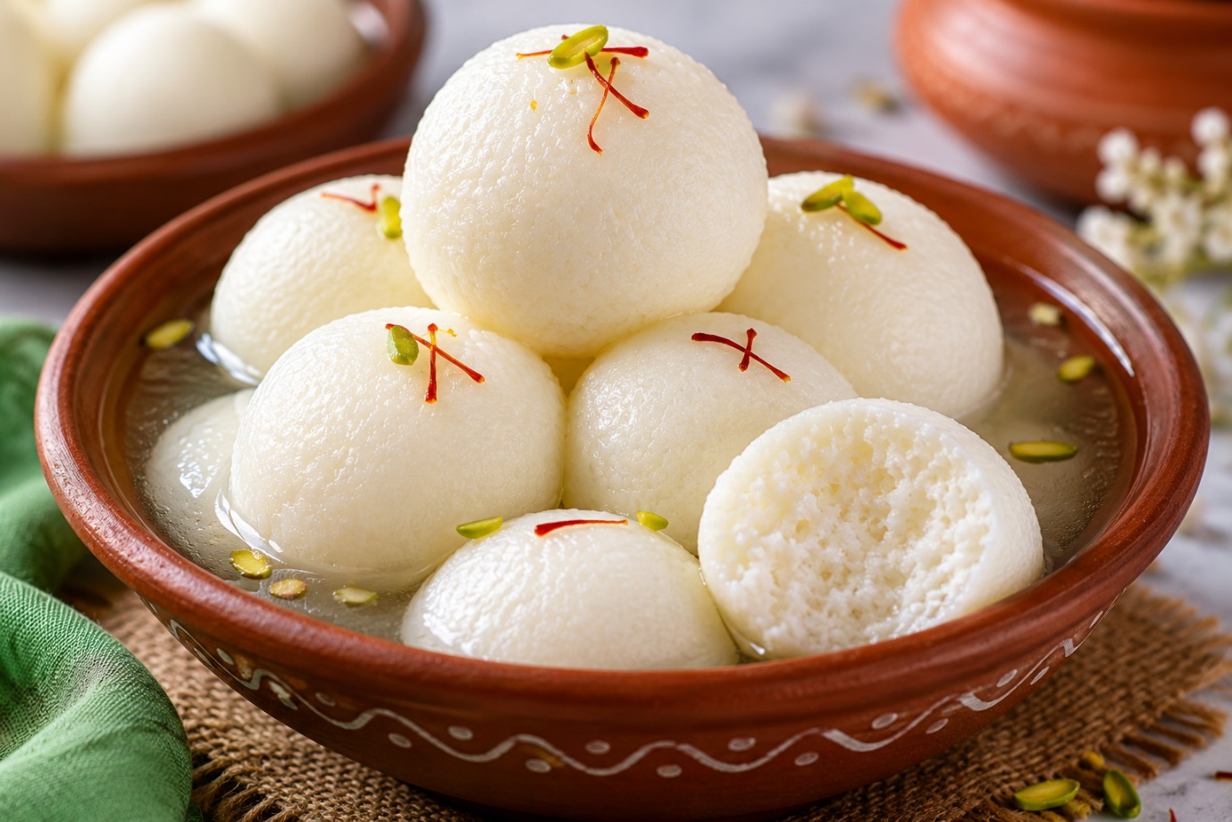
Rosogolla is one of the most popular traditional sweets of Bengal. created by Nabin chandra Das. Made from soft balls of chhena soaked in sugar syrup, this sweet is loved for its spongy texture and refreshing taste. It is a must-have during festivals, family gatherings, and celebrations. Rosogolla has become a symbol of Bengali cuisine and is enjoyed by people all over the world.

<h3> Nolen gurer Sandesh: The joy of Kolkata</h3>

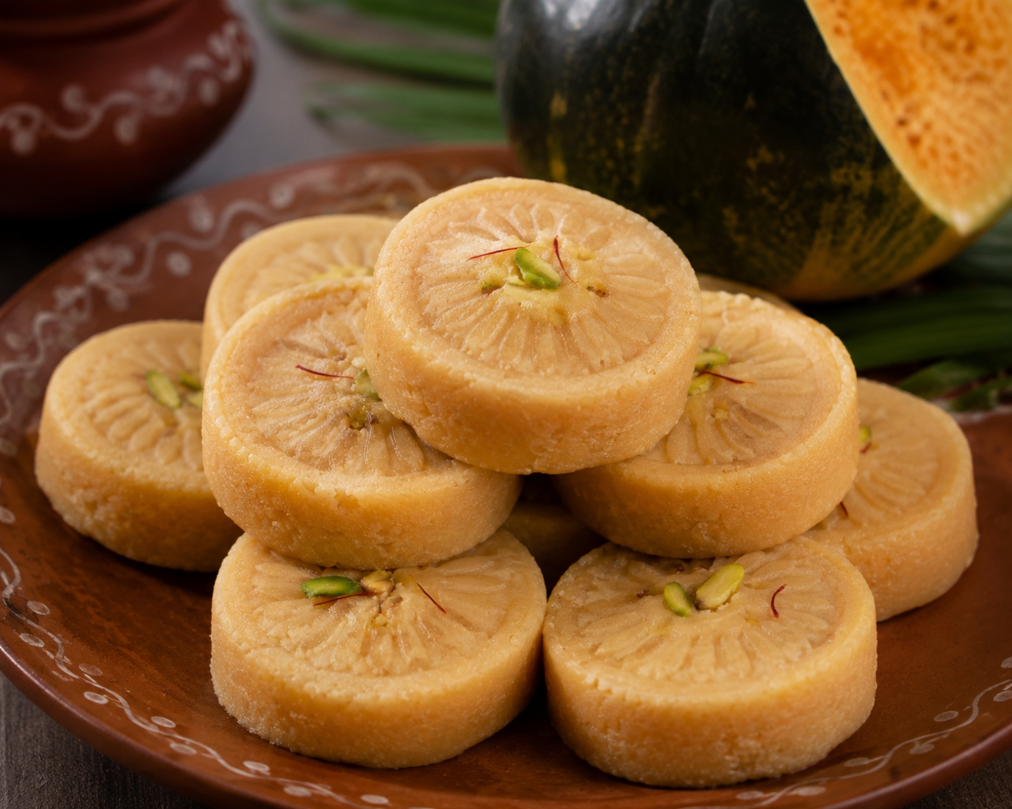

Nolen Gurer Sandesh is a special winter delicacy made from fresh chhena and date palm jaggery, known as nolen gur. Its rich aroma and melt-in-the-mouth texture make it one of the most loved traditional sweets of Kolkata. Sweet lovers eagerly wait for winter to enjoy this seasonal delight.

<h3> Ledikeni: memorable Kolkata</h3>

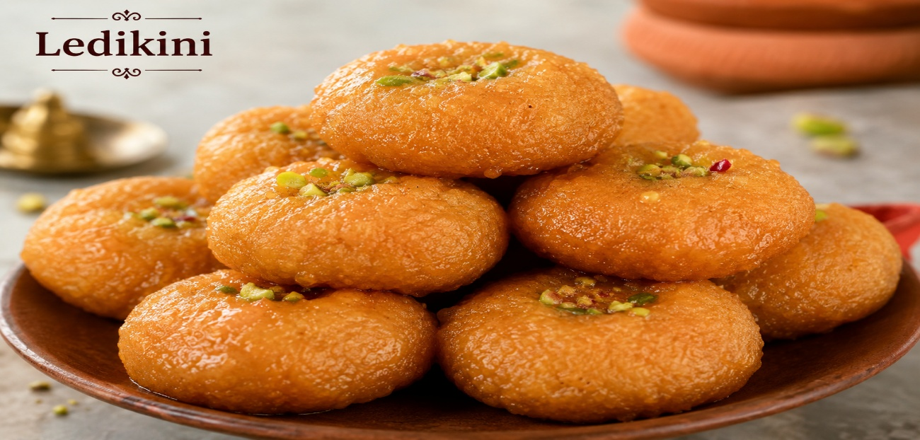

Ledikeni is another famous dessert that reflects Kolkata's rich heritage. It was named after Lady Canning, the wife of Lord Canning, the first Viceroy of India. Made from chhena and flour and soaked in sugar syrup, Ledikeni has a soft texture and a delicious taste. Even today, it remains a favorite among those who enjoy traditional Bengali desserts.

<h2> Other Famous Traditional Sweets That Carry the Rich Heritage of West Bengal</h2>
Besides Burdwan and Kolkata, many towns and districts across West Bengal proudly preserve their own traditional sweets. Over the years, skilled confectioners have passed these delicacies down through generations. As a result, they continue to attract sweet lovers from across the country.

<h3> Sarpuriya: The Famous Traditional Sweets of Krishnanagar</h3>

Sarpuriya is famous of Krishnanagar in Nadia district. Made with layers of cream, milk, and sugar, this rich and delicate desserts is known for its unique texture and flavour. It has been a symbol of Krishnanagar's sweet-making tradition for many years.

<h3> Monohara the famous Traditional Sweets from Janai</h3>

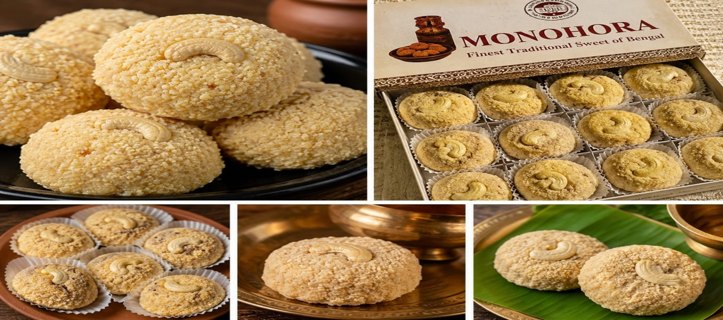

Monohara is a popular of Janai in Hooghly district. It is prepare from Sweet chana and coated with sugar syrup.Today Monohara remains one of the most loved traditional sweets of Bengal.

<h3> Moya from Jaynagar</h3>

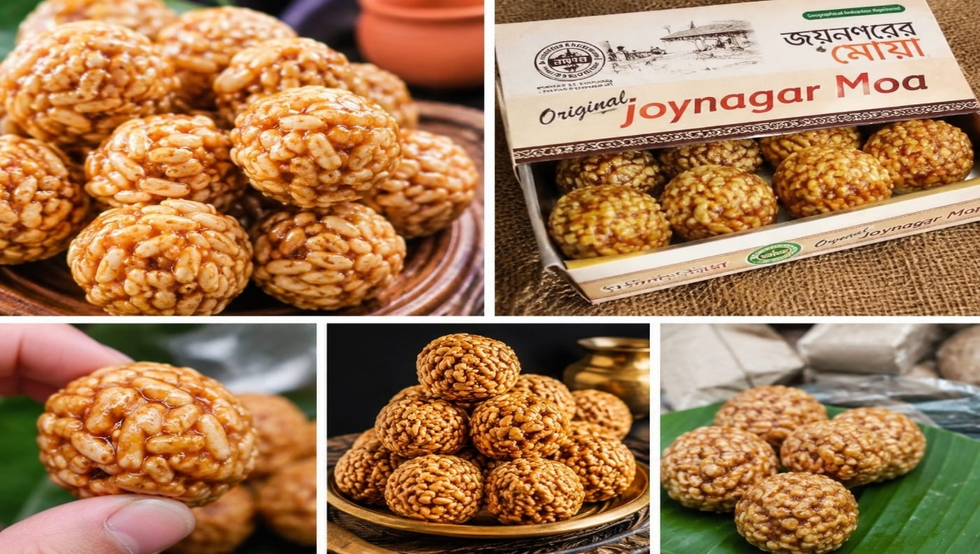

Jaynagar is famous for its delicious Moya. This seasonal sweet contains from Kanakchur khoi and nolen gur. Joynagar's Moya has also received a GI tag for its unique identity.

<h3> Murshidabad Chhanabora</h3>

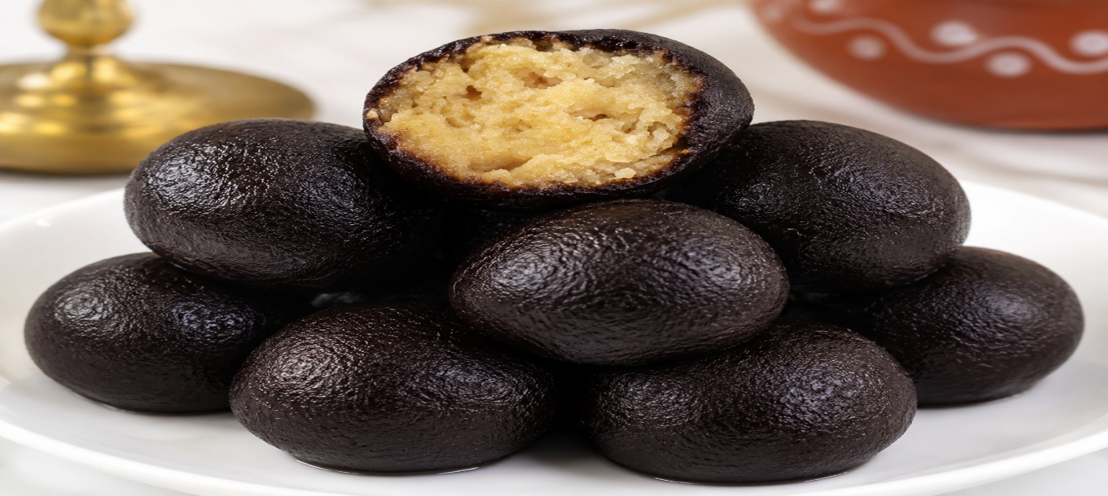

Murshidabad proudly showcases Chhanabora as one of its signature traditional sweets. Skilled sweet makers prepare this delicacy from fresh chhena and then soak it in sugar syrup. As a result, Chhanabora develops a rich taste and a soft texture that delight sweet lovers. Moreover, families and communities often serve this iconic sweet during festivals and special occasions. Consequently, generations of Bengalis have cherished Chhanabora as an important part of Murshidabad's culinary heritage.

<h3>Kamarpukur's White Bonde</h3>

White Bonde is famous from Kamarpukur in the Hooghly district. Unlike the common orange boondi, this sweet has a white colour and a light texture. It is closely associated with the birthplace of Sri Ramakrishna and is popular among visitors and devotees.

<h3>Bishnupur Motichur Laddoo</h3>
Bishnupur in the Bankura district proudly offers its famous Motichur Laddoo. Traditionally, sweet makers prepare this delicacy from tiny gram flour pearls and flavor it with ghee. As a result, people enjoy its rich taste during festivals and religious ceremonies. Moreover, generations of families have cherished this traditional sweet, and therefore, it remains an important part of Bengal's culinary heritage.

<h3>Nabadwip Red Curd</h3>

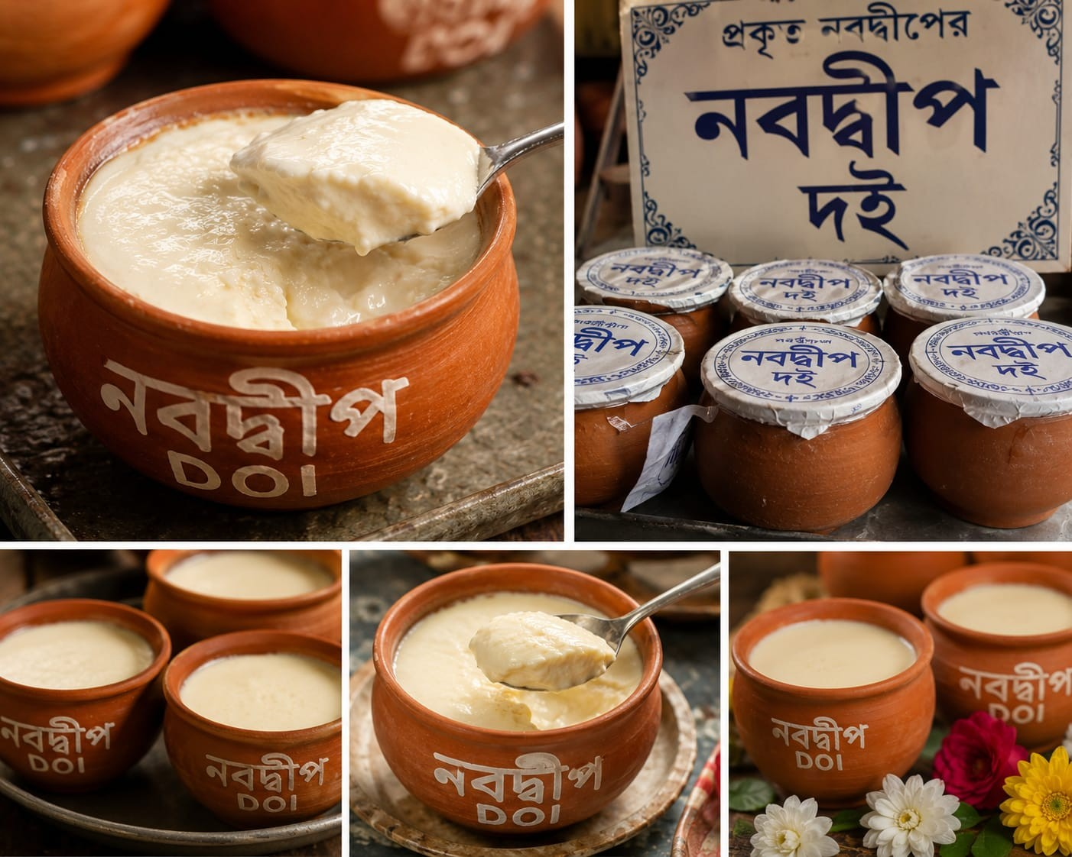

Nabadwip Red Curd, locally known as Lal Doi, is a unique dairy delicacy from Nadia district. Prepared by slowly caramelizing milk and sugar, it develops a rich reddish colour and a creamy texture. Its distinctive taste makes it one of the most cherished traditional sweets of Bengal.

<h2>GI Tag on Traditional Sweets of West Bengal</h2>
Several traditional sweets of West Bengal have received Geographical Indication (GI) tags, which help preserve their authenticity and cultural heritage. Sitabhog and Mihidana from Burdwan and Joynagarer Moya are among the sweets that have earned this recognition.
. Rasagolla get GI Tags in 2017
. Bardhaman Mihidana gets GI Tag In 2017
. Bardhaman Sitabhog get GI Tag In 2017
.Joynagarer Moa get GI Tag in 2015
.Nolen Gurer Sandesh get GI Tag in 2025
. Murshidabad Chhanabora get GI Tag in 2025
. Kamarpukur’s White Bonde get GI Tag in 2025
. Bishnupur Motichur Laddoo get GI Tag in 2025

<h2>Conclusion</h2>
Traditonal are more than just delicious desserts. They form an important part of Bengal's history, culture, and identity. From the royal delicacies of Burdwan and the iconic sweets of Kolkata to the unique flavors of Krishnanagar, Jaynagar, Murshidabad, and Nabadwip, each sweet tells a story of tradition and craftsmanship.
For generations, people have treasured these traditional desserts. Today, they continue to bring joy to festivals, celebrations, and family gatherings. Moreover, several famous deserts have earned GI tags. As a result, Bengal not only preserves its rich sweet-making heritage but also passes these timeless traditions on to future generations.
Whether you enjoy the famous Rosogolla, savor the rich taste of Sarpuriya, or indulge in the seasonal delight of Joynagarer Moya, Bengal's traditional sweets offer a memorable experience. Furthermore, these beloved delicacies reflect the state's enduring love for sweetness and tradition. Therefore, they continue to delight deserts lovers and preserve Bengal's rich culinary heritage for years to come.
Headline: Authentic Traditional Sweets of Bengal
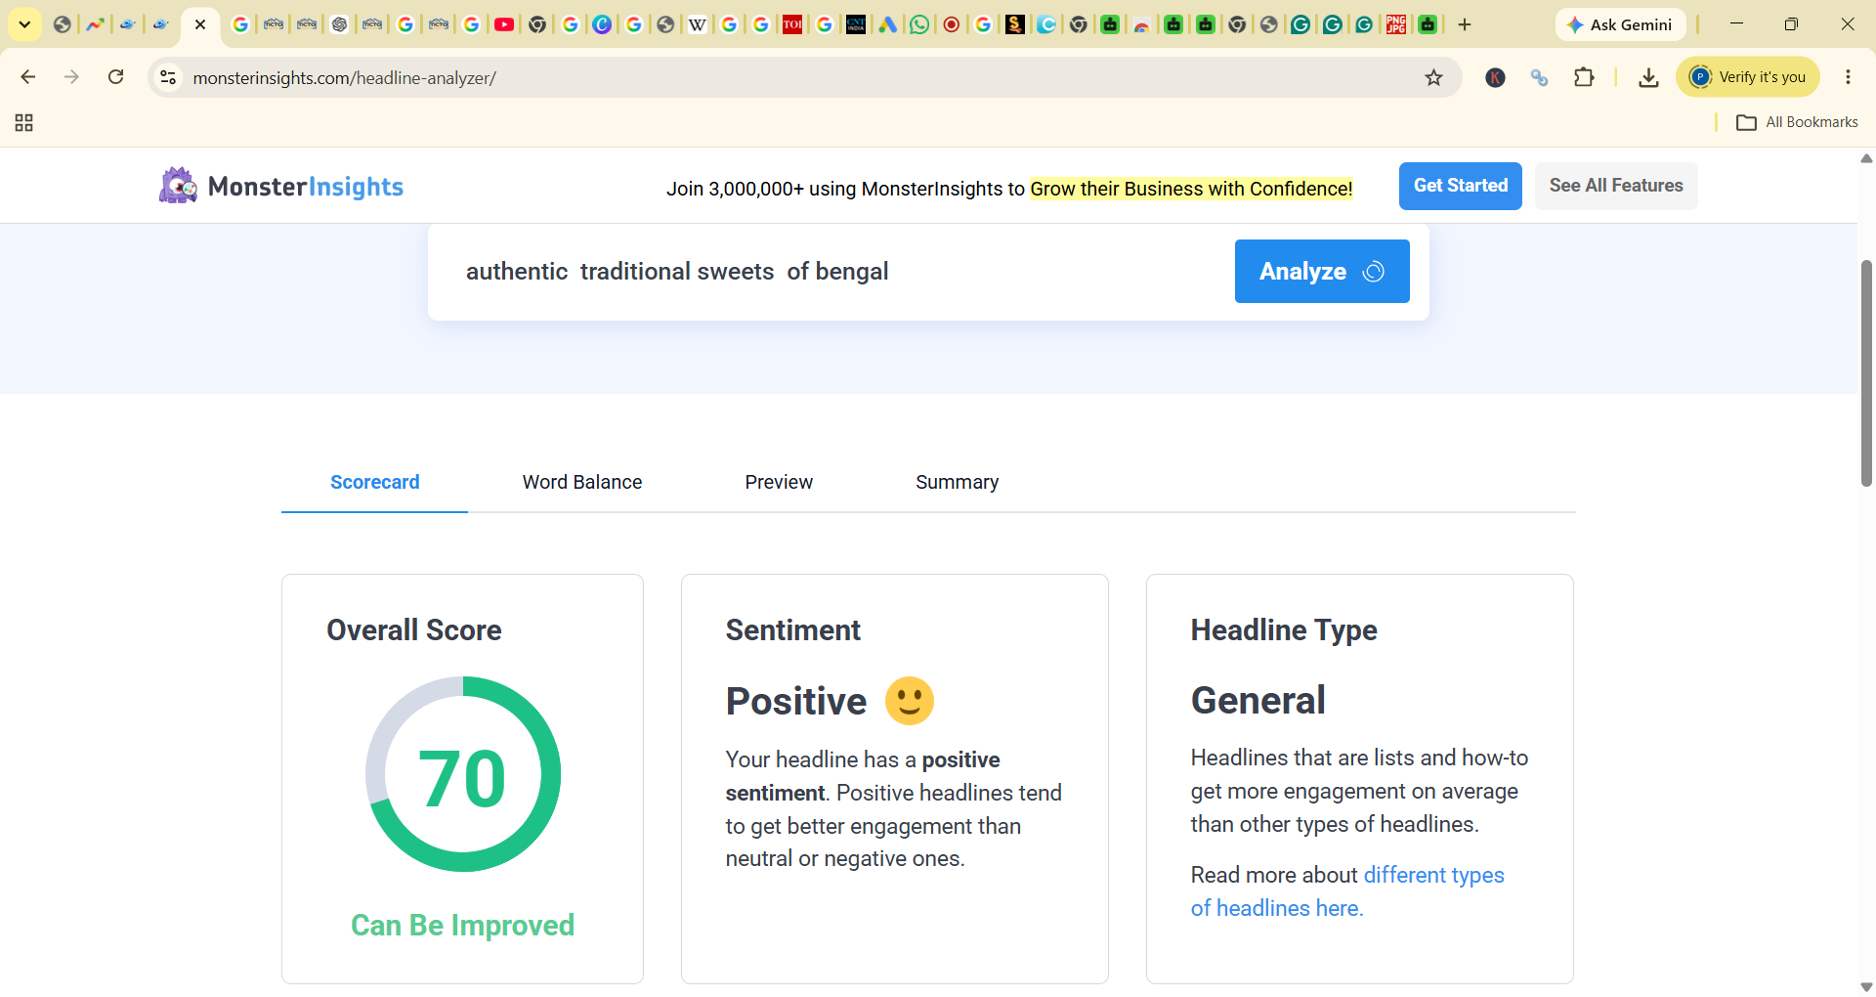

Meta Title: Authentic Traditional Sweets of Bengal: History & taste
Meta Description: Traditional sweets of Bengal bring history and flavor together. Discover Sitabhog, Mihidana, and other authentic sweets and desserts.
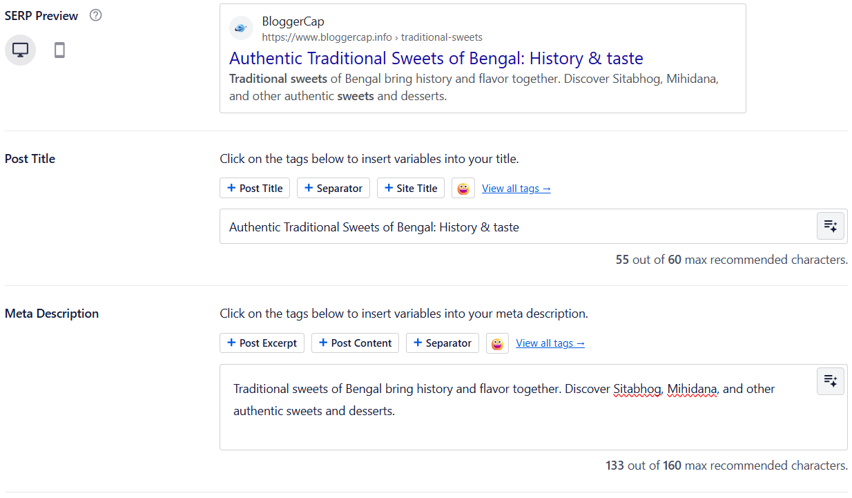
External Link:
- https://tictoinfra.com/blog/other/burdwan-famous-sweets-sitabhog-mihidana-the-pride-of-bardhaman
- https://www.cntraveller.in/story/sweet-west-bengal-sitabhog-gi-tag-kolkata-bardhaman/
- https://www.cadburydessertscorner.com/articles/a-brief-history-of-sitabhog-and-mihidana-burdwans-sweet-treasured-gems
- https://en.wikipedia.org/wiki/Rasgulla
- https://en.wikipedia.org/wiki/Nobin_Chandra_Das
- https://www.slurrp.com/article/history-and-origin-of-ledikeni-a-sweet-delicacy-from-west-bengal-1725264408852
- https://timesofindia.indiatimes.com/life-style/food-news/8-gi-tagged-bengali-sweets-that-are-a-must-try/photostory/131681328.cms

Internal Link:
https://www.bloggercap.info/different-types-of-foods-know-more-about-them/

Focus Keyword and Additional Keyword Optimisation:

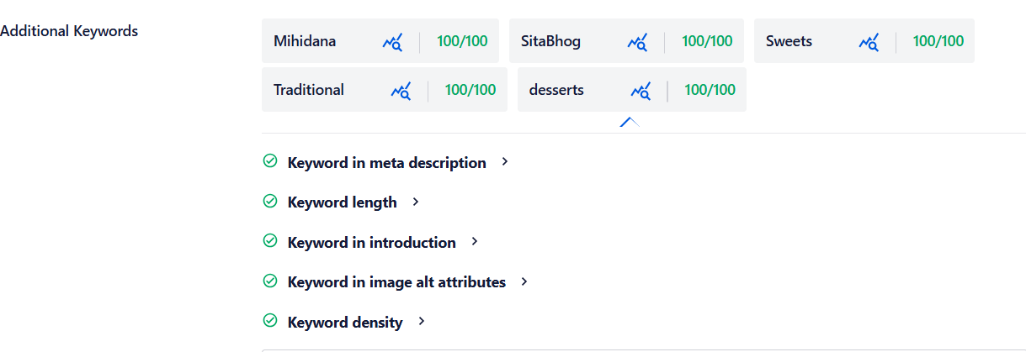

AISEO Score: 97


Section 4: Image optimisation
Image Optimisation:
Feature Image: https://www.bloggercap.info/wp-content/uploads/2026/06/Tradetional-sweets-on-bengal.jpeg
Alt text: Traditional sweets of West Bengal
Title: Traditional sweets of Bengal
Full Name: Traditional sweets on bengal.jpeg
Blog Title | Image URl | File Name | Alt text
Authentic Traditional Sweets of Bengal: History & taste | https://www.bloggercap.info/wp-content/uploads/2026/06/Traditional-sweets-2-of-burdwan.jpeg | Traditional-sweets-2-of-burdwan.jpeg | Traditional Sweets of Burdwan
Authentic Traditional Sweets of Bengal: History & taste | https://www.bloggercap.info/wp-content/uploads/2026/06/traditional-sweets-Janai-Monohora-1-300x240.jpeg | traditional-sweets-Janai-Monohora-1-300x240.jpeg | Traditional Desserts of monohara
Authentic Traditional Sweets of Bengal: History & taste | https://www.bloggercap.info/wp-content/uploads/2026/06/traditional-sweets-joynagar-moya-300x240.jpeg | traditional-sweets-joynagar-moya-300x240.jpeg | Traditional Sweets
Authentic Traditional Sweets of Bengal: History & taste | https://www.bloggercap.info/wp-content/uploads/2026/06/Tradional-sweets-6.jpg | Tradional-sweets-6.jpg | Traditional Sweets
Authentic Traditional Sweets of Bengal: History & taste | https://www.bloggercap.info/wp-content/uploads/2026/06/Traditional-sweets-of-burdwan-5.jpeg.jpg | Traditional-sweets-of-burdwan-5.jpeg.jpg | Traditional sweets mihidana
Authentic Traditional Sweets of Bengal: History & taste | https://www.bloggercap.info/wp-content/uploads/2026/06/Traditional-sweets-Rosogolla.png | Traditional-sweets-Rosogolla.png | Traditional sweets rosogolla
Authentic Traditional Sweets of Bengal: History & taste | https://www.bloggercap.info/wp-content/uploads/2026/06/traditional-sweets-of-bengal-Nalen-gur-er-sandesh.png | traditional-sweets-of-bengal-Nalen-gur-er-sandesh.png | traditional sweets Nalen gurer sandesh
Authentic Traditional Sweets of Bengal: History & taste | https://www.bloggercap.info/wp-content/uploads/2026/06/Traditional-sweets-ledikini.png | Traditional-sweets-ledikini.png | Traditional Sweets
Authentic Traditional Sweets of Bengal: History & taste | https://www.bloggercap.info/wp-content/uploads/2026/06/traditional-sweets-chanabora.png | traditional-sweets-chanabora.png | Traditional sweets Chanabora (Murshidabad)
Authentic Traditional Sweets of Bengal: History & taste | https://www.bloggercap.info/wp-content/uploads/2026/06/Traditional-sweets-nabadwip-kheer-doi.jpeg | Traditional-sweets-nabadwip-kheer-doi.jpeg | Traditional sweets
External Link:
- https://tictoinfra.com/blog/other/burdwan-famous-sweets-sitabhog-mihidana-the-pride-of-bardhaman
- https://www.cntraveller.in/story/sweet-west-bengal-sitabhog-gi-tag-kolkata-bardhaman/
- https://www.cadburydessertscorner.com/articles/a-brief-history-of-sitabhog-and-mihidana-burdwans-sweet-treasured-gems
- https://en.wikipedia.org/wiki/Rasgulla
- https://en.wikipedia.org/wiki/Nobin_Chandra_Das
- https://www.slurrp.com/article/history-and-origin-of-ledikeni-a-sweet-delicacy-from-west-bengal-1725264408852
- https://timesofindia.indiatimes.com/life-style/food-news/8-gi-tagged-bengali-sweets-that-are-a-must-try/photostory/131681328.cms
Internal Link: https://www.bloggercap.info/different-types-of-foods-know-more-about-them/

Table of Contents:
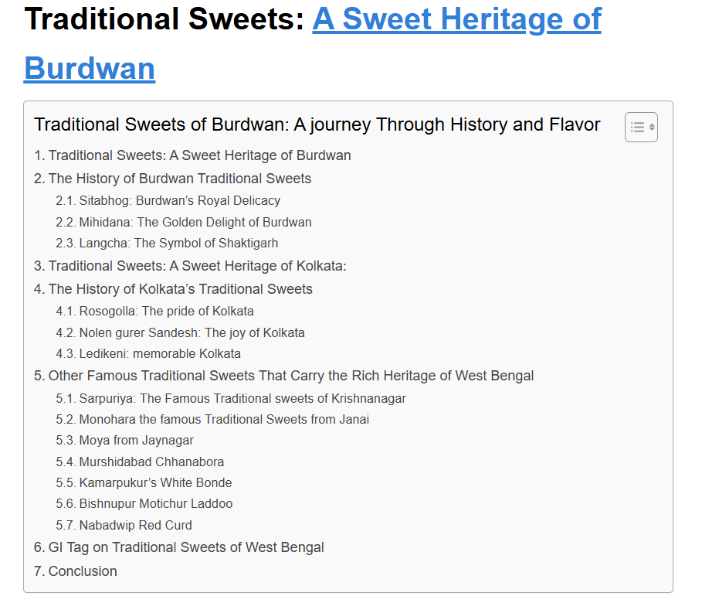

Section 5: Technical SEO Optimisation:

Schema:

<script type="application/ld+json">

{

"@context": "https://schema.org",

"@type": "BlogPosting",

"mainEntityOfPage": {

"@type": "WebPage",

"@id": "https://www.bloggercap.info/wp-admin/post.php?post=16326&action=edit"

},

"headline": "Authentic Traditional Sweets of Bengal: History & taste",

"description": "Traditional sweets of Bengal bring history and flavor together. Discover Sitabhog, Mihidana, and other authentic sweets and desserts.",

"image": [

"https://www.bloggercap.info/wp-content/uploads/2026/06/Traditional-sweets-of-burdwan-1024x819.jpeg",

"https://www.bloggercap.info/wp-content/uploads/2026/06/Tradional-sweets-6-300x300.jpg",

"https://www.bloggercap.info/wp-content/uploads/2026/06/ChatGPT-Image-Jun-21-2026-08_45_43-PM-300x240.jpg",

"https://www.bloggercap.info/wp-content/uploads/2026/06/Traditional-sweets-langcha-300x200.jpg",

"https://www.bloggercap.info/wp-content/uploads/2026/06/Traditional-sweets-Rosogolla-300x200.png",

"https://www.bloggercap.info/wp-content/uploads/2026/06/traditional-sweets-of-bengal-Nalen-gur-er-sandesh-300x240.png",

"https://www.bloggercap.info/wp-content/uploads/2026/06/Traditional-sweets-ledikini-300x200.png",

"https://www.bloggercap.info/wp-content/uploads/2026/06/traditional-sweets-Janai-Monohora-1-300x240.jpeg",

"https://www.bloggercap.info/wp-content/uploads/2026/06/traditional-sweets-joynagar-moya-300x240.jpeg",

"https://www.bloggercap.info/wp-content/uploads/2026/06/traditional-sweets-chanabora-300x240.png",

"https://www.bloggercap.info/wp-content/uploads/2026/06/Traditional-sweets-nabadwip-kheer-doi-300x240.jpeg"

],

"author": {

"@type": "Person",

"name": "Puja Karmakar",

"url": "https://www.blogger.com/about/"

},

"publisher": {

"@type": "Organization",

"name": "Bloggercap",

"logo": {

"@type": "ImageObject",

"url": "https://www.bloggercap.info/?p=16326&preview=true"

}

},

"datePublished": "2026-06-22",

"dateModified": "2026-06-22"

}

</script>

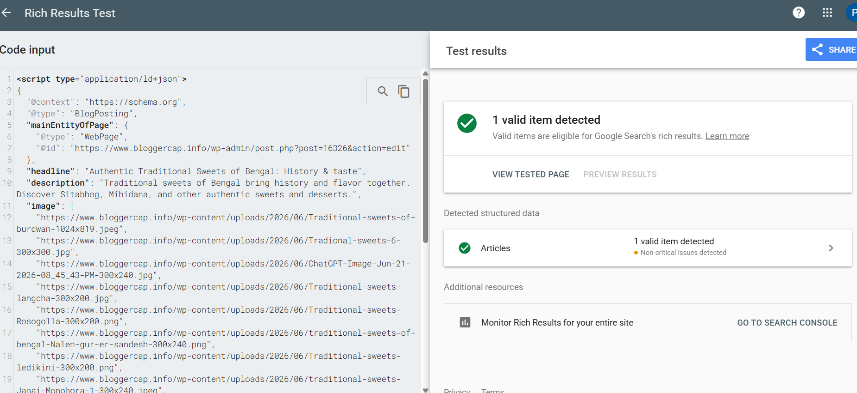Section 6 : Open Graph: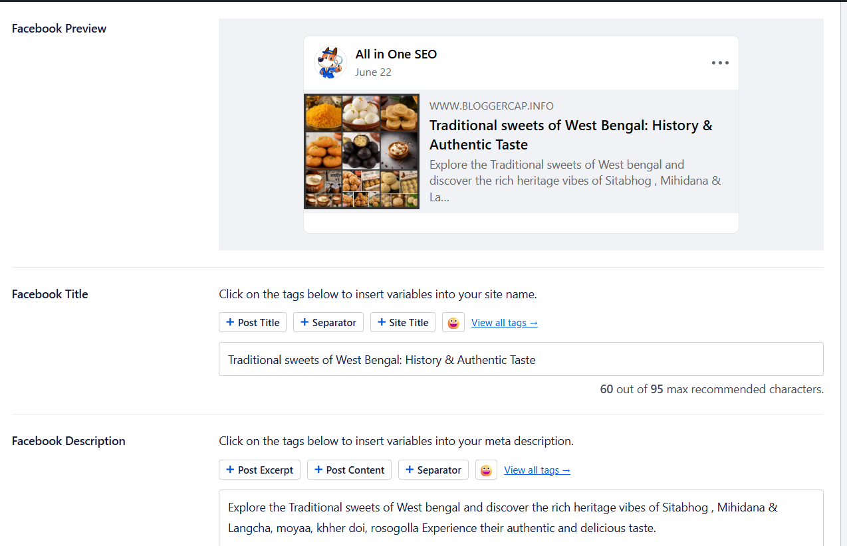
Sitemap:


Canonical Tag:
rel=“canonical”href=”https://www.bloggercap.info/bengal-traditional-sweets/

Section 6: Plagiarism Check:

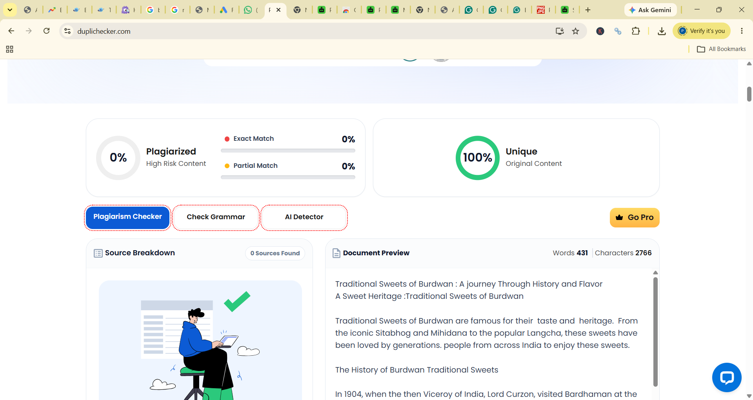

Conclusion: This is the blog on the topic of Traditional Sweets of Bengal. It is an important part of Bengali culture and heritage. Here include various famous sweets like Rosogolla, Mihidana, Sitabhog, Moa, Monohara, Ledikini, etc. It is my first project on Bloggercap, and also I was excited.

